**Rule Composer**

The role of the composer is essentially to create a job. This task is managed by users. However, users typically don't have SQL knowledge or access. Therefore, our GPM has developed a tool for users to create their own jobs. This tool is called the Rule Composer.

Select and click the Role Composer.



Within every rule, even the last one, the rule composer lists all the existing jobs.

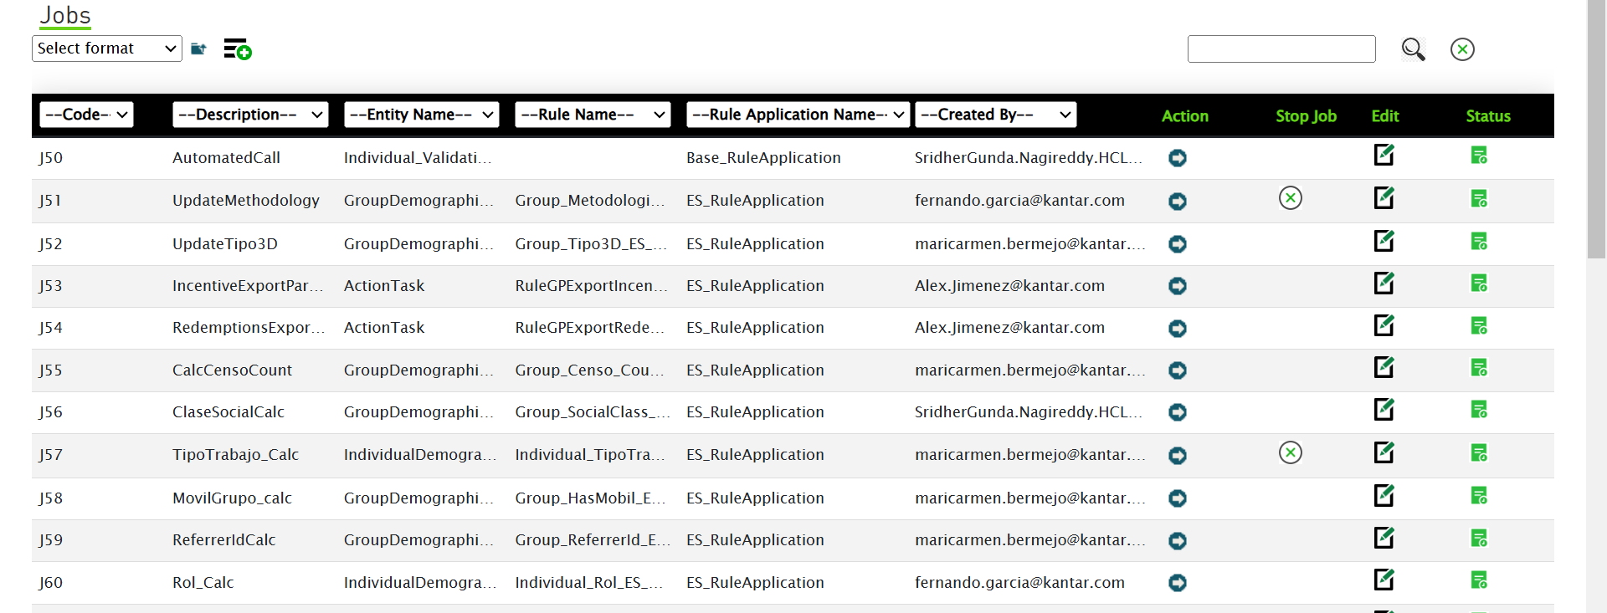

After clicking the Rule Composer. select and click the Add New Record.

After clicking 'Add New Record,' a new window opens where you can create the job.

Click the job name box and provide the job name.



Select and click the country. If access to multiple countries were available, the entire country list would be visible.



The use of this tool is to allow users to compose rules.

Using this rule composer, users can schedule activities on the SQL side.

Normally, we have a few jobs deployed on the SQL server, but users cannot execute or change the script in SQL. However, in GPM, users can.

In production, users created a job named 'Auto Automated Call' for Spain region and provided a query.

You can call this a query window, and this is the result output."

Here, it shows the query output. If we click the execution button, it will display the script's output.



Now, it is showing the business ID, panel code, and country code.

After the job executes the script, the output will be displayed. This is the output data.

Here is the rule application, specifically the base rule application.

It includes a version and the entity list, all configured in the rule application.

Using this data, the rule application will process it.

It can update, insert, send emails, or perform any communication tasks.

The activities done by the rule application need to be provided by our support team.

No need to provide any details here.

These are all created by users, including the script, so we don't create any rule composer jobs on any of the sites.

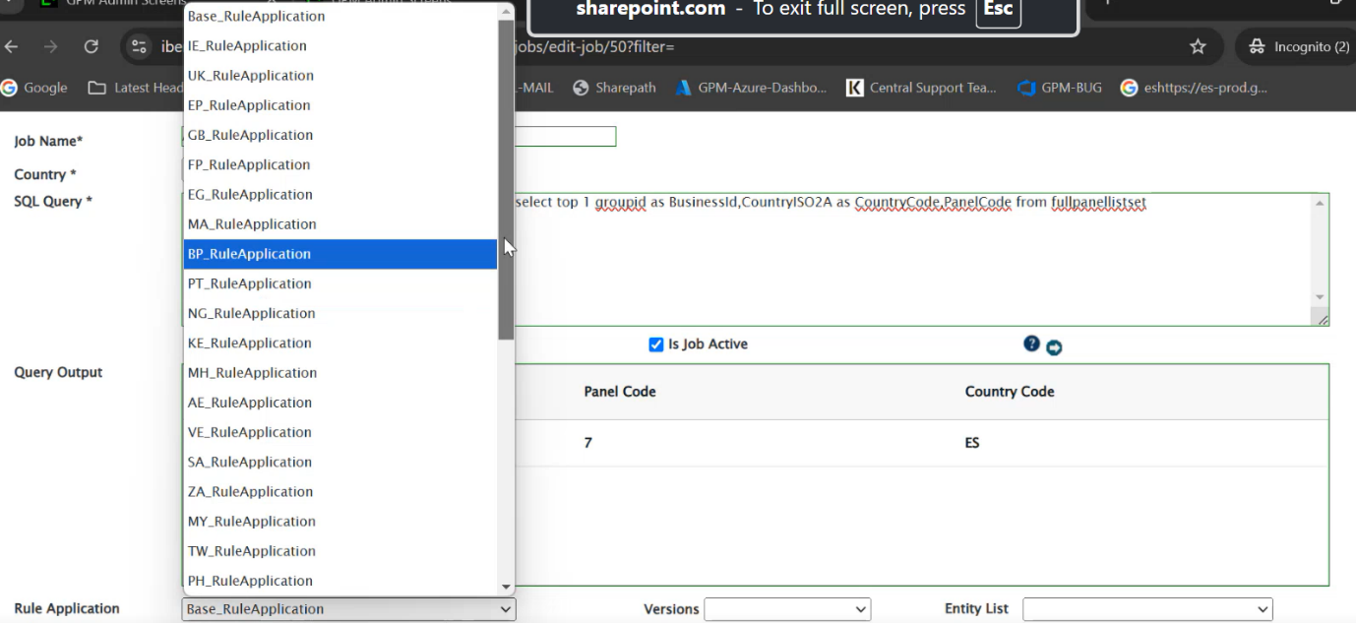

Users can create the rule composer and execute the jobs.

If they encounter any issues while executing the jobs or if the job is executed but the data is not updated as expected, they will reach out to us to check the job and the data. This is how users can create the jobs.

It is one line of code, If the user updates anything or adds two or three more lines, that will be the new version.

This is one way the user handles the rule. Composer sites are used, and another one is the business rule.

Then it gets populated with the latest version. You need to select the latest version and the entity where the rule is written.

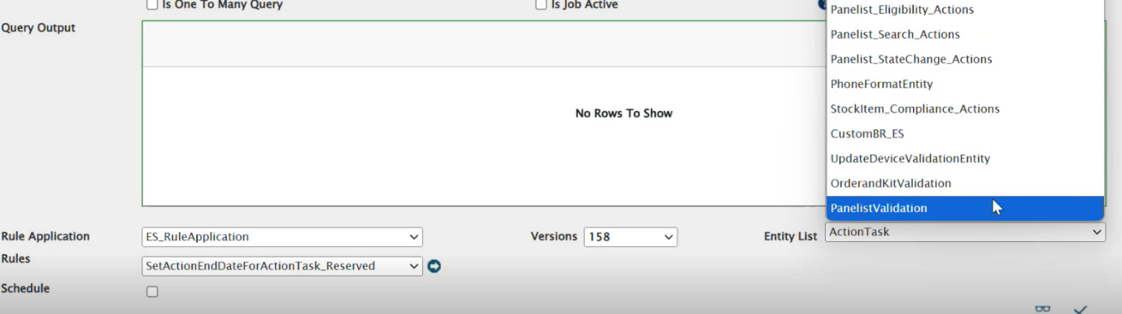

Select the rule you have written in IR Author. These should be selected correctly.

If not, your rule might not be executed correctly.

The expectation from the job depends on how you select your rule application and version.

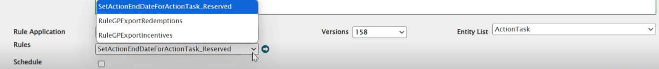At the end, the data is sent to the IR, which calls the rule application based on the selected version.

The entity list and the rule should be set properly by the user.

Sometimes users might make mistakes, such as selecting the wrong version, and then say the job is not working. We need to check whether the rule and the expectations are correct.



See, hear you can see the job code and description.

What is the job for? It is for the entity and role application.

Here you can see the status, when we click here, it will give us the status of the job.

It will show if it is completed, in progress, or failed. If it failed, it would show the error.

Everything can be seen from this page. Users can also execute the job manually from this screen."

Sometimes the job is not executed as scheduled, but users can run it manually if needed."

In that case, they will come here and run it from the execution action."

Once you execute the job, it will run in the Rule Composer and send the data to IR Author."

The operations are already written, and after the data is updated, it will be processed and inserted into the database."

On this screen, we can see how many records are processed and get all the information."

You can export the result to Excel or CSV from here."

You can search by job runtime to see any job executed previously, like last month or last week. This is called job audit, showing the job ID and audit ID for the particular execution time."

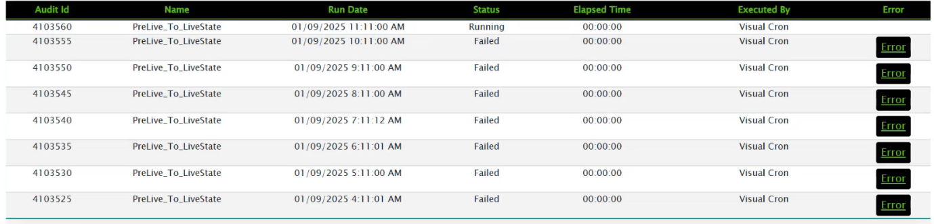

The job is currently in a running state, but the previous run failed."

We can see why it failed by clicking on the error, which shows 'execution timeout expired' due to the SQL server."

In our GPM system, there is a 10-minute timeout set for executing queries."

If it exceeds this time, the script will be killed, showing a 'timeout expired' error."

If the job is completed, we can see the details here, including job actions and business rules."